# Implementation

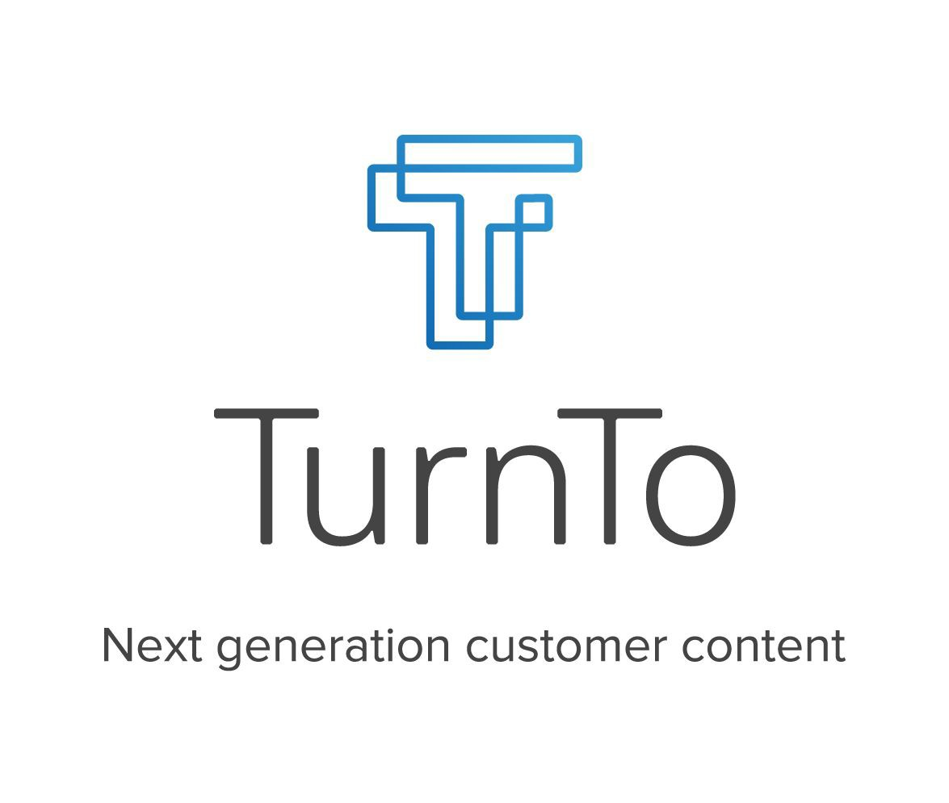

# Overview

## Table of Contents

Table of Contents 2

Setup 3

Configuration 5

Setting Up Your Site 5

Initial Setup and General Settings 6

Configure the Mobile Landing Page 9

Set up TurnTo Services 11

Set up Your Feeds 12

Set up TurnTo Widgets and Teasers 16

Set up Search Settings 23

Custom Code 29

Global Includes 29

Product Detail Page 31

Category and Search Pages 33

## Setup

This TurnTo® LINK integration contains three cartridges, named int_turnto_core, int_turnto_pipelines, and int_turnto_controllers. The cartridge has two pipelines named TurnTo and TurnToFeeds. The TurnTo pipeline contains five entry points: GetProductQA, GetProductReviews, MobileLanding, VisualContentsPinboard, CheckoutCommentsPinboard. The TurnToFeeds pipeline consists of five entry points: ExportHistoricalOrders, ExportCatalog, ExportHistoricalOrdersByDate, ImportAverageRatings, and ImportUserGeneratedContent. The entry points in TurnToFeeds should only be used to setup background jobs and/or workflows.

For each pipeline in the int_turnto_pipelines cartridge, there is an equivalent controller in the int_turnto_controllers cartridge. In order to set up the controller entry points as jobs, you will need to download and follow the installation instructions for the Integration Framework, located here: <https://github.com/turnto/salesforce-commerce-cloud>

The ExportHistoricalOrders entry point exports all of the customer orders that have been placed in the last X days (this number is configurable via site preference). The exported data is then automatically pushed to the TurnTo® system via HTTP. A temporary file, named “exportOrder.txt”, is written to a TurnTo folder within the Import/Export folder. The file is left on the files system after the job is finished. The file is overwritten each time the export job is run.

The ExportCatalog entry point exports all of the products from the catalog. The exported data is then automatically pushed to the TurnTo® system. A temporary file, named “exportCatalog.txt”, is created in a TurnTo folder within the Import/Export folder. The file is left on the files system after the job is finished. The file is overwritten each time the export job is run.

The ExportHistoricalOrdersByDate entry point exports all of the customer orders that have been placed on X date (this date is configurable via site preference). This job is meant to be manually run, in the event that order(s) from a specific date were not uploaded successfully in the past. The exported data is then automatically pushed to the TurnTo® system via HTTP. A temporary file, named “exportOrder.txt”, is written to a TurnTo folder within the Import/Export folder. The file is left on the files system after the job is finished. The file is overwritten each time the export job is run.

The ImportAverageRatings entry point imports all of the average star ratings for your product SKUs from the SKU-to-Average Star Rating Feed. NOTE: You will need to contact your TurnTo® support representative to enable this feed.

The ImportUserGeneratedContent entry point imports all of the user-generated content (Questions, Answers, Replies, Comments, and Reviews) for all items on your site, and stores it in a searchable attribute on the product data. NOTE: You will need to contact your TurnTo® support representative to enable the XML version of this feed.

## Configuration

### Setting Up Your Site

1. Create a TurnTo account on [www.turnto.com/register](http://www.turnto.com/register) if you don't already have one.
2. Make sure your TurnTo contact has added your site to the [turnto.com](http://turnto.com/) system.
3. Make sure your TurnTo contact has made you a TurnTo account manager of your site. Once you are a manager of your site, you will see a new navigation area on the left with your site name and links to your settings, reporting and moderation.
4. Add cartridges to site cartridge path
   1. In Demandware Business Manager, Click Sites in the Administration section
   2. Click "Manage Sites" link
   3. Click the name of your site. For instance, SiteGenesis.
   4. Click the "Settings" tab.
   5. Option A: If using pipelines, fill in the cartridges field: int_turnto_pipelines:int_turnto_core:storefront  
      *Note: replace storefront with your store cartridge(s)*
   6. Option B: If using controllers, fill in the cartridges field: int_turnto_controllers:int_turnto_core:storefront  
      *Note: replace storefront with your store cartridge(s)*
   7. Click Apply
5. Add cartridges to business manager cartridge path
   1. In Demandware Business Manager, Click Sites in the Administration section
   2. Click "Manage Sites" link
   3. Click the "Business Manager" link
   4. Option A: If using pipelines, fill in the cartridges field: int_turnto_pipelines:int_turnto_core:storefront  
      *Note: replace storefront with your store cartridge(s)*
   5. Option B: If using controllers, fill in the cartridges field: int_turnto_controllers:int_turnto_core:storefront  
      *Note: replace storefront with your store cartridge(s)*
   6. Click Apply

### Initial Setup and General Settings

#### Upload and Import Metadata

1. In Demandware Business Manager, click "Site Development" in the Administration section
2. Click "Import & Export" and then, under the section Import & Export Files, click "Upload"
3. Choose the file located in *int_turnto_core/metadata/TurnToMetadata.xml* and click "Upload"
4. Return back to the "Import & Export" page, and then, under Meta Data, click "Import"
5. Select the file you just uploaded, and click "Next". Once the file validates, click "Import"

#### Upload and Import Job Schedules

1. Open the file int_turnto_core/metadata/TurnToJobSchedules.xml, and edit it
2. Modify all references to site-id="SiteGenesis" in the file, replacing them with the ID of your site
3. In Demandware Business Manager, click "Operations" in the Administration section
4. Click "Import & Export" and then, under the section Import & Export Files, click "Upload"
5. Choose the file you just edited (int_turnto_core/metadata/TurnToJobSchedules.xml) and click "Upload"
6. Return back to the "Import & Export" page, and then, under Job Schedules, click "Import"
7. Select the file you just uploaded, and click "Next". Once the file validates, click "Import"

#### TurnTo General Settings

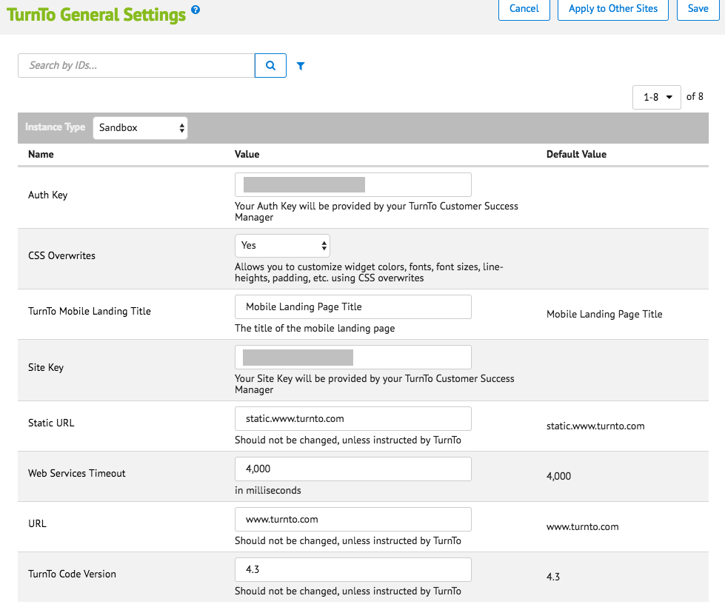

1. In Demandware Business Manager, click "Custom Preferences" in the Merchant Tools section, under Site Preferences
2. Click on "TurnTo General Settings" and then fill out the following information (* means required):
   1. Auth Key*: <YOUR AUTH KEY> (Your Auth Key will be provided by your TurnTo Customer Success Manager)
   2. CSS Overwrites: "Yes" if you want to be able to customize the widgets, "No" otherwise
   3. Turnto Mobile Landing Title: This will be the title of the mandatory Mobile Landing Page, default is "Mobile Landing Page Title"
   4. Site Key*: <YOUR SITE KEY> (Your Site Key will be provided by your TurnTo Customer Success Manager)
   5. Static URL: default is "[static.www.turnto.com](http://static.www.turnto.com/)" (Note: no http:// or https:// or trailing slashes)
   6. Web Services Timeout: number of milliseconds before services time out, default is 4000
   7. URL: default is "[www.turnto.com](http://www.turnto.com/)" (Note: no http:// or https:// or trailing slashes)
   8. TurnTo Code Version: This number will replace the version number in the JS script URLs, default is 4.3 (Should not be changed, unless instructed by TurnTo)



1. Click Apply

### Configure the Mobile Landing Page

The mobile landing page is required for all TurnTo® implementations - It is a container that displays certain TurnTo® screens for mobile users and is referred to in the functional for all TurnTo® products (documentation: <https://turnto.zendesk.com/hc/en-us/articles/207959416-Mobile-Landing-Page-Required-4-3)>

By default, the Mobile Landing page is included at the TurnTo-MobileLanding pipeline endpoint, i.e. http://<CLIENT DOMAIN>/on/demandware.store/Sites-<SITE NAME>-Site/default/TurnTo-MobileLanding



#### Add the Mobile Landing Page URL to your TurnTo Settings



1. Log in to your TurnTo account and go to the "Q&A Settings" link for your site.

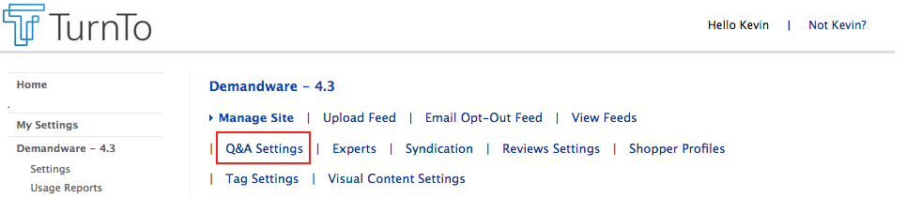

1. Scroll down to the bottom of the page, and enter your Mobile Landing page URL into the field named "TurnTo Mobile Page", and click Update.

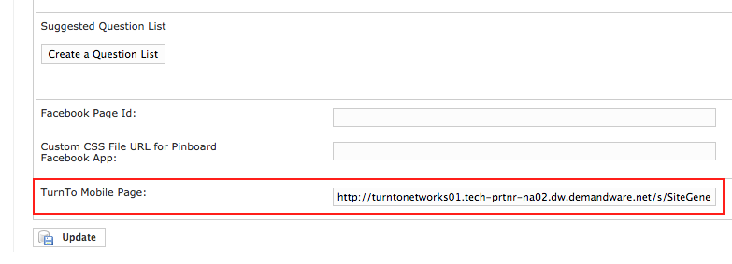

#### Create a Pipeline URL for the Mobile Landing Page in Business Manager (optional)

1. You can create a vanity URL for the MobileLanding pipeline in Business Manager by going to Merchant Tools, <SITE NAME>, Site URLs, URL Rules, and clicking on the "Pipeline URLs" tab.
2. In the "New Alias:" field, add an alias (i.e. "mobilelanding") and the pipeline ("TurnTo-MobileLanding"), and click Apply.

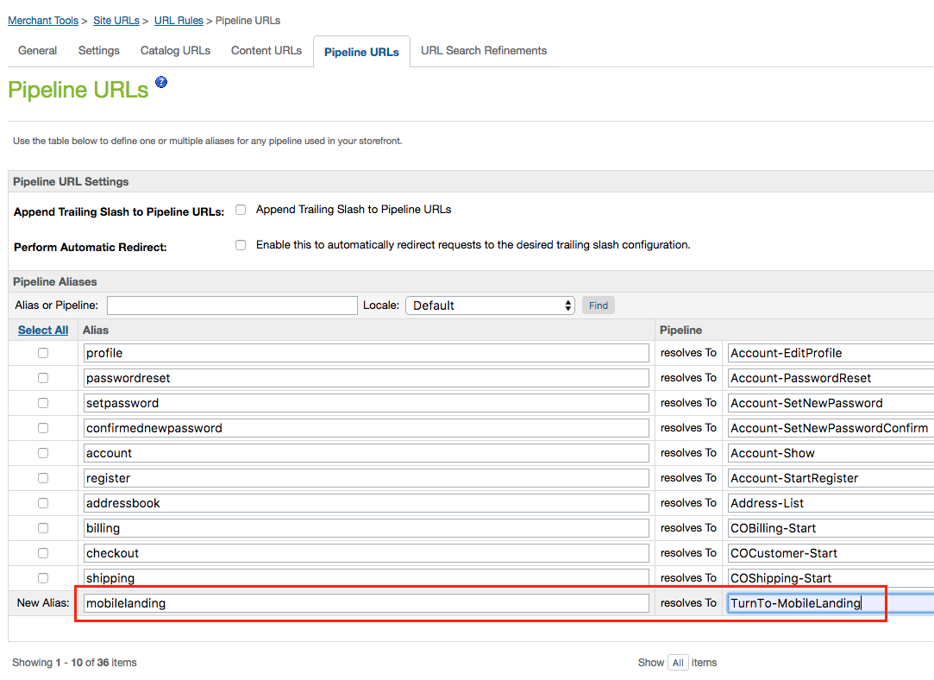

1. Then, go back to the TurnTo® settings page from the previous section, and update the TurnTo Mobile Page field to the new URL.

### Set up TurnTo Services

#### Create Profiles and Credentials

1. In Demandware Business Manager, go to Administration, then Services.
2. Click the “Profiles” tab
3. Click “New”
4. Fill in the following values:  
   Name: turnto-static  
   Timeout (ms): 4000
5. Click “Apply”
6. Click “Back to List”
7. Click the “Credentials” tab
8. Click “New”
9. Fill in the following values:  
   Name: turnto-static  
   URL: <http://static.www.turnto.com>
10. Click "Apply"
11. Click "Back to List"

#### Create Services

1. On the Services page, click the "Services" tab
2. Click “New”
3. Fill in the following values:  
   Name: turnto.http.static.QA.get  
   Type: HTTP  
   Enabled: <checked>  
   Service Mode: Live  
   Log Name Prefix: turnto-static-qa  
   Profile: turnto-static   
   Credentials: turnto-static
4. Click “Apply”
5. Click “Back to List”
6. Click “New”
7. Fill in the following values:
8. Name: turnto.http.static.reviews.get
9. Type: HTTP
10. Enabled: <checked>
11. Service Mode: Live
12. Log Name Prefix: turnto-static-reviews
13. Profile: turnto-static
14. Credentials: turnto-static
15. Click Apply. All services are now configured.

### Set up Your Feeds

#### TurnTo Javascript Feed

Purpose: Collects real-time order data on the order confirmation page

Documentation: <https://turnto.zendesk.com/hc/en-us/articles/208262393-Javascript-Feed-4-3>

1. In Demandware Business Manager, click "Custom Preferences" in the Merchant Tools section, under Site Preferences
2. Click on "TurnTo Feeds" and then fill out the following information:  
   Javascript Feed (on Order Confirmation): "Yes" if you want to enable the collection of real-time order data on the order confirmation page, "No" otherwise
3. Click Apply

#### TurnTo Catalog Export Feed



Purpose: Generates a catalog feed in the TurnTo format and uploads it to [turnto.com](http://turnto.com/) via HTTP for processing.

Documentation:

<https://turnto.zendesk.com/hc/en-us/articles/208262373-Catalog-Feed-4-3>

NOTE: The catalog feed includes links to product images. By default, the demandware image store is used. If you use a third party to store your images you’ll need to modify ExportCatalog.js in the int_turnto_core cartridge to point to your image store.

NOTE: A domain name must be added to TurnTo Settings for feeds to be uploaded. Otherwise, there will be an error screen.

1. Login to your Demandware Business Manager
2. Click the Operations link in the Administration section
3. Click Job Schedules
4. Click "TurnTo Catalog Export"
5. Configure your desired run frequency, as well as any notifications, and make sure "Enabled" is checked.
6. Click Apply
7. Recommendation: Run this job schedule once manually, to perform the initial load of your product catalog into the TurnTo system

#### TurnTo Historical Order Feed - Ongoing

Purpose: Generates an order feed in the TurnTo format and uploads it to [turnto.com](http://turnto.com/) via HTTP for processing.

Documentation:

<https://turnto.zendesk.com/hc/en-us/articles/207959666-Historical-Order-Feed-4-3>

NOTE: A domain name must be added to TurnTo Settings for feeds to be uploaded. Otherwise, there will be an error screen.

1. Login to your Demandware Business Manager
2. Click the Site Preferences Link in the Merchant Tools section for your site
3. Click Custom Preferences and then TurnTo Feeds
4. Update the "Historical Order Days" preference to the number of days you want to be exported (typically 2 or 3)
5. Click the Operations link in the Administration section
6. Click Job Schedules
7. Click "TurnTo Historical Order Export (Ongoing)"
8. Configure your desired run frequency, as well as any notifications, and make sure "Enabled" is checked
9. Click Apply

#### TurnTo SKU-to-Average Rating Feed (Optional)

Purpose: Downloads and imports the nightly sku-to-average-rating feed for display of teaser on the category/search pages

Documentation (see "Option #1"): <https://turnto.zendesk.com/hc/en-us/articles/208262323-SKU-to-Average-Rating-Feed-Optional-4-3>

1. Enable the Sku Average Rating Feed Pull in your TurnTo Settings. (Contact your TurnTo support representative to enable.)
2. After the nightly feed is generated, verify that you can access the feed via a browser at: <http://static.www.turnto.com/static/export/YOURSITEKEYHERE/YOURAUTHKEYHERE/turnto-skuaveragerating.xml>
3. Login to your Demandware Business Manager



1. Click the Operations link in the Administration section
2. Click Job Schedules
3. Click "TurnTo Import Average Ratings"
4. Configure your desired run frequency, as well as any notifications, and make sure "Enabled" is checked.
5. Click Apply
6. After the job has successfully run, products present in the feed will have the following custom attributes populated on the Product record:  
   turntoAverageRating  
   turntoReviewCount  
   turntoRelatedReviewCount  
   turntoCommentCount

#### TurnTo User Generated Content Feed (Optional)

Purpose: Downloads and imports the Customer Generated Content XML feed for all products, so that the TurnTo content can be searchable on the storefront.

Documentation: <https://turnto.zendesk.com/hc/en-us/articles/208262293-CGC-Feed-SEO-4-3>

1. Contact your TurnTo support representative to enable the XML version of the sitewide Customer Generated Content Feed.
2. After the nightly feed is generated, verify that you can access the feed via a browser at: <http://static.www.turnto.com/static/export/YOURSITEKEYHERE/YOURAUTHKEYHERE/turnto-ugc.xml>
3. Login to your Demandware Business Manager
4. Click the Operations link in the Administration section
5. Click Job Schedules
6. Click "TurnTo Import User Generated Content"
7. Configure your desired run frequency, as well as any notifications, and make sure "Enabled" is checked.
8. Click Apply
9. After the job has successfully run, products present in the feed will have the following custom attributes populated on the Product record:  
   turntoUserGeneratedContent

#### TurnTo Historical Order Feed - Specific Date (Optional)

Purpose: Generates an order feed for a specific date in the TurnTo format and uploads it to [turnto.com](http://turnto.com/) via HTTP for processing. This job is meant to be run manually, in the event that orders got skipped by the JS Feed or the Historical Feed - Ongoing.

Documentation: <https://turnto.zendesk.com/hc/en-us/articles/207959666-Historical-Order-Feed-4-3>

NOTE: A domain name must be added to TurnTo Settings for feeds to be uploaded. Otherwise, there will be an error screen.

1. Login to your Demandware Business Manager
2. Click the Site Preferences link in the Merchant Tools section for your site
3. Click Custom Preferences and then TurnTo Feeds
4. Update the "Historical Order Date" preference to the specific date you want to export
5. Click the Operations link in the Administration section
6. Click Job Schedules
7. Click "TurnTo Historical Order Export (Specific Date)"
8. Click "Run"



### Set up TurnTo Widgets and Teasers

#### TurnTo Q&A

Features Include:

* Q&A & Reviews Combo Teaser (if both are enabled): <https://turnto.zendesk.com/hc/en-us/articles/207959326-Q-A-and-Reviews-Displaying-the-Q-A-Teaser-and-Reviews-Teaser-on-the-same-line-4-3>
* Q&A Teaser (if only Q&A is enabled): <https://turnto.zendesk.com/hc/en-us/articles/208272843-Q-A-Custom-Item-Teaser-Launching-Widget-From-Under-a-Tab-4-3>

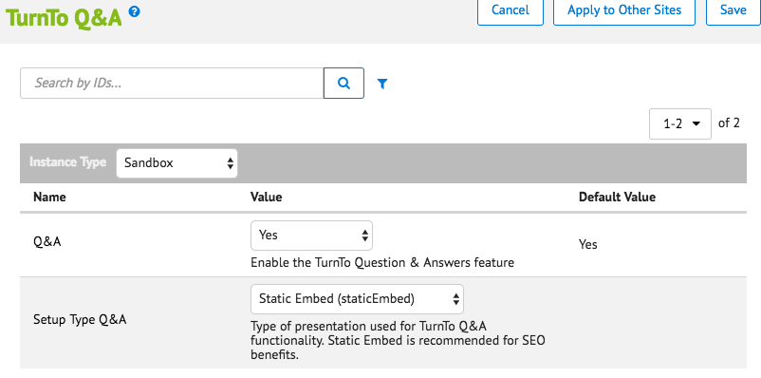

1. In Demandware Business Manager, click "Custom Preferences" in the Merchant Tools section, under Site Preferences
2. Click on "TurnTo Q&A" and then fill out the following information:
3. Q&A: "Yes" if you want to enable the Question & Answers feature, "No" otherwise
4. Setup Type Q&A: Type of presentation used for TurnTo Q&A functionality. "Static Embed" is recommended for SEO benefits.
5. Click Apply

#### TurnTo Reviews

Features Include:

* Q&A & Reviews Combo Teaser (if both are enabled): <https://turnto.zendesk.com/hc/en-us/articles/207959326-Q-A-and-Reviews-Displaying-the-Q-A-Teaser-and-Reviews-Teaser-on-the-same-line-4-3>
* Reviews Teaser (if only Reviews are enabled): <https://turnto.zendesk.com/hc/en-us/articles/208262133-Reviews-Custom-Teaser-Launching-Widget-Under-a-Tab-4-3>

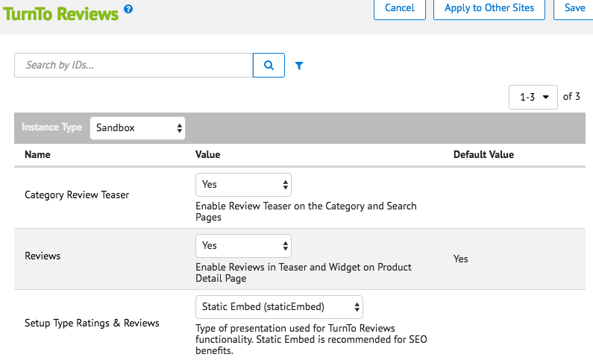

1. In Demandware Business Manager, click "Custom Preferences" in the Merchant Tools section, under Site Preferences
2. Click on "TurnTo Reviews" and then fill out the following information:
3. Category Review Teaser: "Yes" if you want to enable the review teaser on the category and search pages, "No" otherwise
4. Reviews: "Yes" if you want to enable the Reviews feature on the product detail page, "No" otherwise
5. Setup Type Ratings & Reviews: How TurnTo Reviews are integrated into your site. "Static Embed" is recommended for SEO benefits.
6. Click Apply

#### TurnTo Visual Content

Features Include:

* Visual Content Gallery Row Widget: <https://turnto.zendesk.com/hc/en-us/articles/207702936-Visual-Content-Gallery-Row-Widget>
* Visual Content Pinboard:  
  <https://turnto.zendesk.com/hc/en-us/articles/210589443-Visual-Content-Pinboard-4-3>

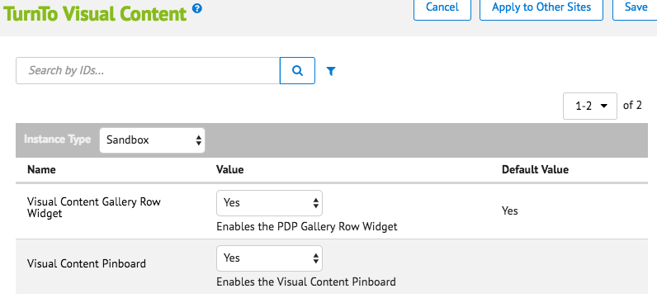

1. In Demandware Business Manager, click "Custom Preferences" in the Merchant Tools section, under Site Preferences
2. Click on "TurnTo Visual Content" and then fill out the following information:
3. Visual Content Gallery Row Widget: "Yes" if you want to enable the PDP Gallery Row Widget, "No" otherwise.
4. Visual Content Pinboard: "Yes" if you want to enable the Visual Content Pinboard, "No" otherwise.  
   By default, the Visual Content Pinboard page is included at the TurnTo-VisualContentPinboard pipeline endpoint, i.e. http://<CLIENT DOMAIN>/on/demandware.store/Sites-<SITE NAME>-Site/default/TurnTo-VisualContentPinboard
5. Click Apply

#### TurnTo Checkout Comments

Features Include:

* Checkout Comments Capture Widget: <https://turnto.zendesk.com/hc/en-us/articles/208258993-Comment-Capture-Widget-4-3>
* Checkout Comments PDP Widget: <https://turnto.zendesk.com/hc/en-us/articles/208259113-Checkout-Comments-PDP-Widget-4-3>
* Checkout Comments Pinboard:  
  <https://turnto.zendesk.com/hc/en-us/articles/209186526-Checkout-Comments-Pinboard-4-3>
* Checkout Comments Pinboard Teaser: <https://turnto.zendesk.com/hc/en-us/articles/211770063-Checkout-Comments-Pinboard-Teaser-4-3>

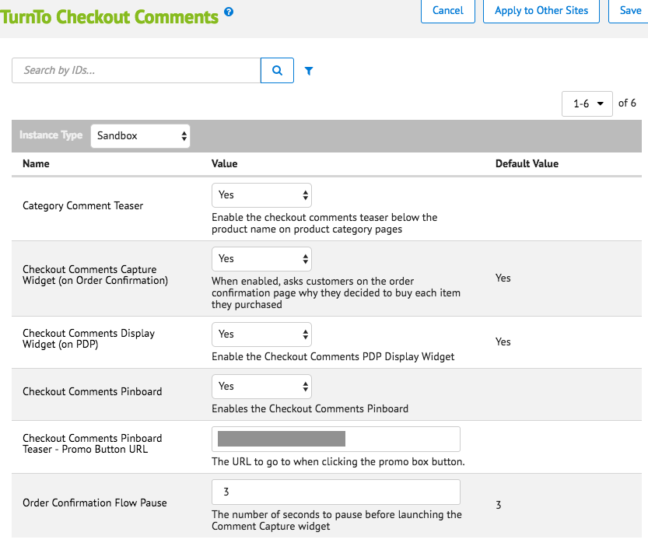

1. In Demandware Business Manager, click "Custom Preferences" in the Merchant Tools section, under Site Preferences
2. Click on "TurnTo Checkout Comments" and then fill out the following information:
   1. Category Comment Teaser: "Yes" if you want to enable the checkout comments teaser below the product name on category/search pages, "No" otherwise
   2. Checkout Comments Capture Widget (on Order Confirmation): When enabled, asks customers on the order confirmation page why they decided to buy each item they purchased
   3. Checkout Comments Display Widget (on PDP): "Yes" if you want to enable the checkout comments widget on the product detail page, "No" otherwise
   4. Checkout Comments Pinboard: "Yes" if you want to enable the checkout comments pinboard and pinboard teaser, "No" otherwise  
      By default, the Checkout Comments Pinboard page is included at the TurnTo-CheckoutCommentsPinboard pipeline endpoint, i.e. http://<CLIENT DOMAIN>/on/demandware.store/Sites-<SITE NAME>-Site/default/TurnTo-CheckoutCommentsPinboard
   5. Checkout Comments Pinboard Teaser Promo Button URL: The URL to go to when clicking the promo box button in the checkout comments pinboard teaser
   6. Order Confirmation Flow Pause: The number of seconds to pause before launching the Comment Capture widget, default is 3
3. Click Apply

##### TurnTo Checkout Comments Pinboard Teaser

In order to get the pinboard teaser working on the category pages, it needs to be enabled for each category you would like it to appear on.

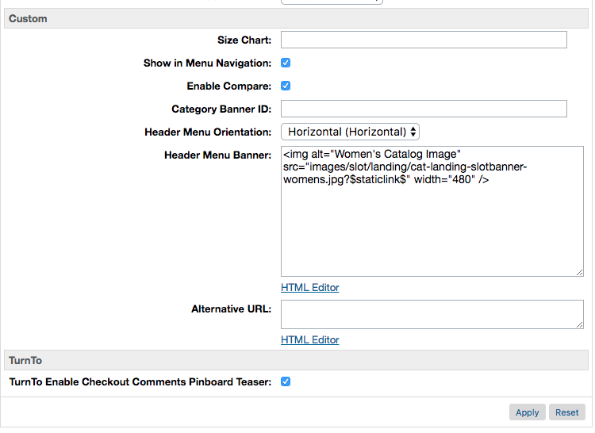

1. In Demandware Business Manager, click "Products and Catalogs" in the Merchant Tools section
2. Click Catalogs, then click your site's storefront catalog
3. Navigate to the category you want to enable the teaser for, and then click "Edit"
4. Click the "Category Attributes" tab
5. Find the "TurnTo Enable Checkout Comments Pinboard Teaser" attribute, and check it.
6. Click Apply
7. The category page will only show the pinboard teaser if ALL of the following conditions are met:
   1. Custom site preference "Checkout Comments Pinboard" under the TurnTo Checkout Comments group is set to true
   2. Custom site preference "Checkout Comments Pinboard Teaser - Promo Button URL" under the TurnTo Checkout Comments group has a value
   3. Custom category attribute "TurnTo Enable Checkout Comments Pinboard Teaser" is set to true
   4. The category contains at least 4 products (as defined by the Catalog Feed) with 4 buyer comments. This minimum requirement is on the TurnTo side, and can not be changed.

### Set up Search Settings

#### Make User Generated Content Searchable

NOTE: The necessary data comes from the User Generated Content Feed

1. Login to your Demandware Business Manager
2. Click the Search link under Merchant Tools for your site
3. Click Searchable Attributes
4. Click "New" and add attribute "custom.turntoUserGeneratedContent" to the list, then give it an appropriate Boost Factor
5. Click Apply
6. Go back to Search, and click Search Indexes
7. Check the box for "Product Index" and click Rebuild
8. Now, when you search for specific text that exists in a review, comment, or question, the matching products will show up in the search results

#### Configure Average Star Ratings as a Search Refinement

NOTE: The necessary data comes from the SKU-to-Average-Rating Feed

1. Login to your Demandware Business Manager
2. Click the Products and Catalogs link under Merchant Tools for your site
3. Click Catalogs
4. Click the storefront catalog of your site, and then click "Edit" on the top right
5. Click the tab for Search Refinement Definitions, and click "New"

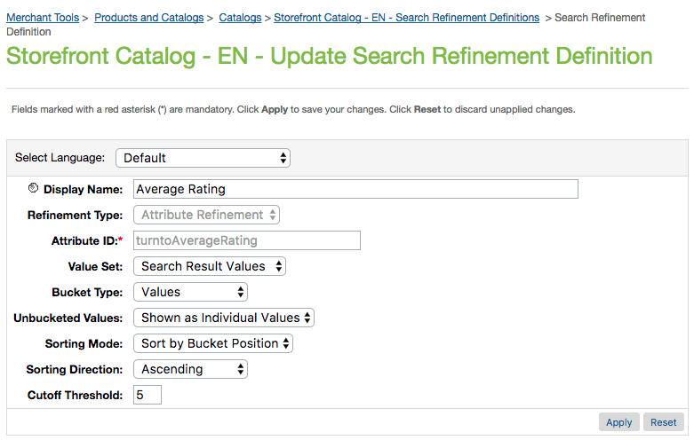

1. Update the following settings:  
   Display Name: Average Rating  
   Refinement Type: Attribute Refinement  
   Attribute ID: turntoAverageRating  
   Value Set: Search Result Values  
   Bucket Type: Values  
   Unbucketed Values: Show as Individual Values  
   Sorting Mode: Sort by Bucket Position  
   Sorting Direction: Ascending  
   Cutoff Threshold: 5
2. Click Apply
3. Under Attribute Bucket Refinements, add the following buckets as shown in the image below:

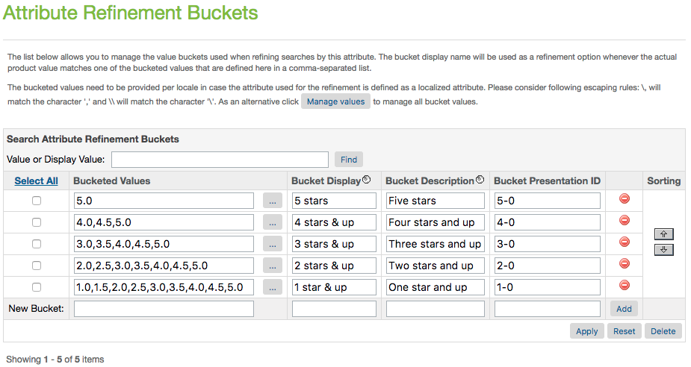

1. Click Apply
2. Go to Search, under the Merchant Tools for your site
3. Click Search Indexes
4. Check the box for "Product Index" and click Rebuild
5. You should now see the refinement for Average Rating on your category and search pages, as seen below:

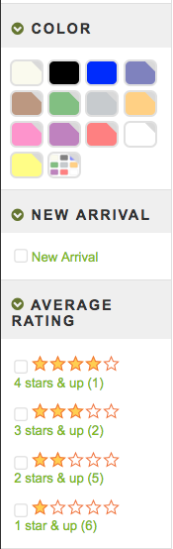

#### Configure Average Star Ratings as a Sortable Filter

NOTE: The necessary data comes from the SKU-to-Average-Rating Feed

1. Login to your Demandware Business Manager
2. Click the Search link under Merchant Tools for your site
3. Click Sorting Rules
4. Click "New" to add a new sorting rule, with the following settings:  
   ID: turnto-ratings  
   Description: Sorts by TurnTo Average Rating
5. With "turnto-ratings" now selected, click Add to add attributes.
6. Select the attribute "TurnTo Average Rating (product.custom.turntoAverageRating), sort direction by "Descending", text relevancy "N/A", and click Apply.

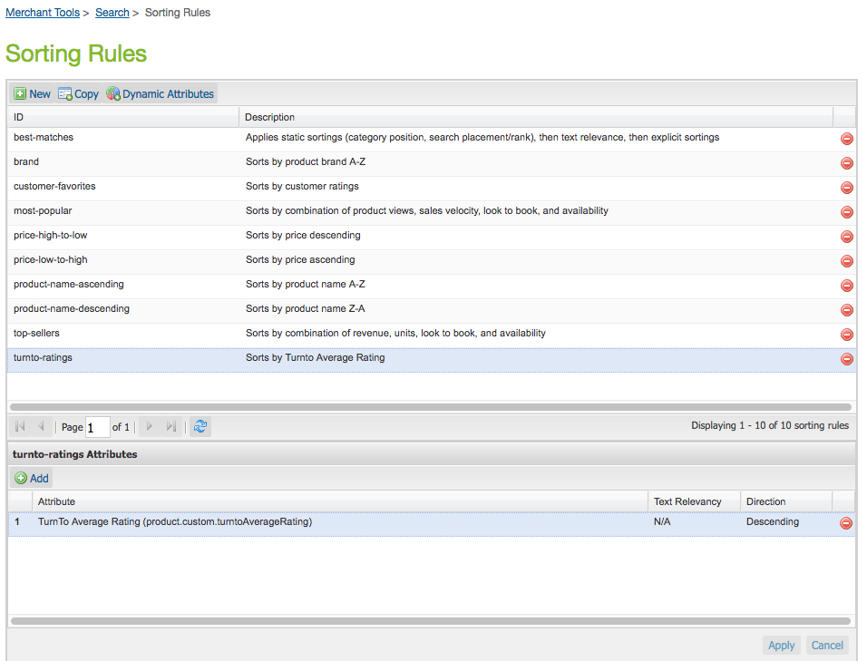

1. Go back to Search, under the Merchant Tools for your site
2. Click Storefront Sorting Options
3. Add a new sorting option, with the following settings:  
   ID: ratings  
   Sorting Rule: turnto-ratings  
   Display Name: Average Rating



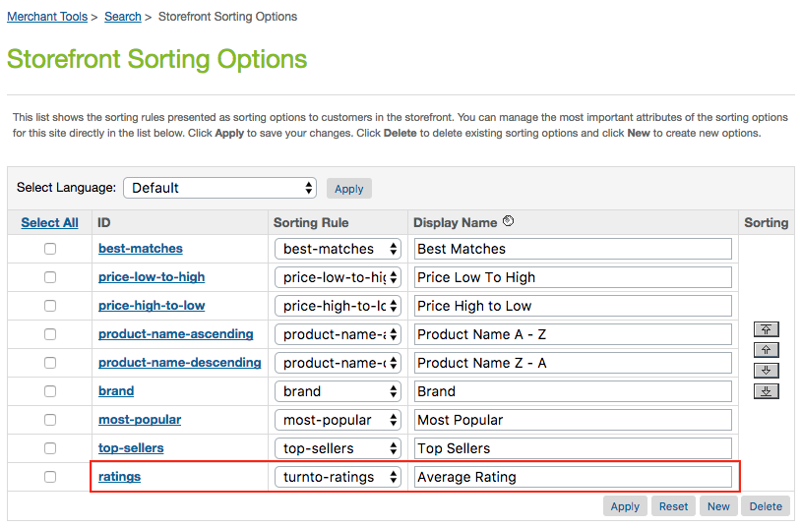

1. Click Apply
2. Go back to Search, under the Merchant Tools for your site
3. Click Search Indexes
4. Check the box for "Product Index" and click Rebuild
5. You should now see the refinement for Average Rating on your category and search pages, as seen below:

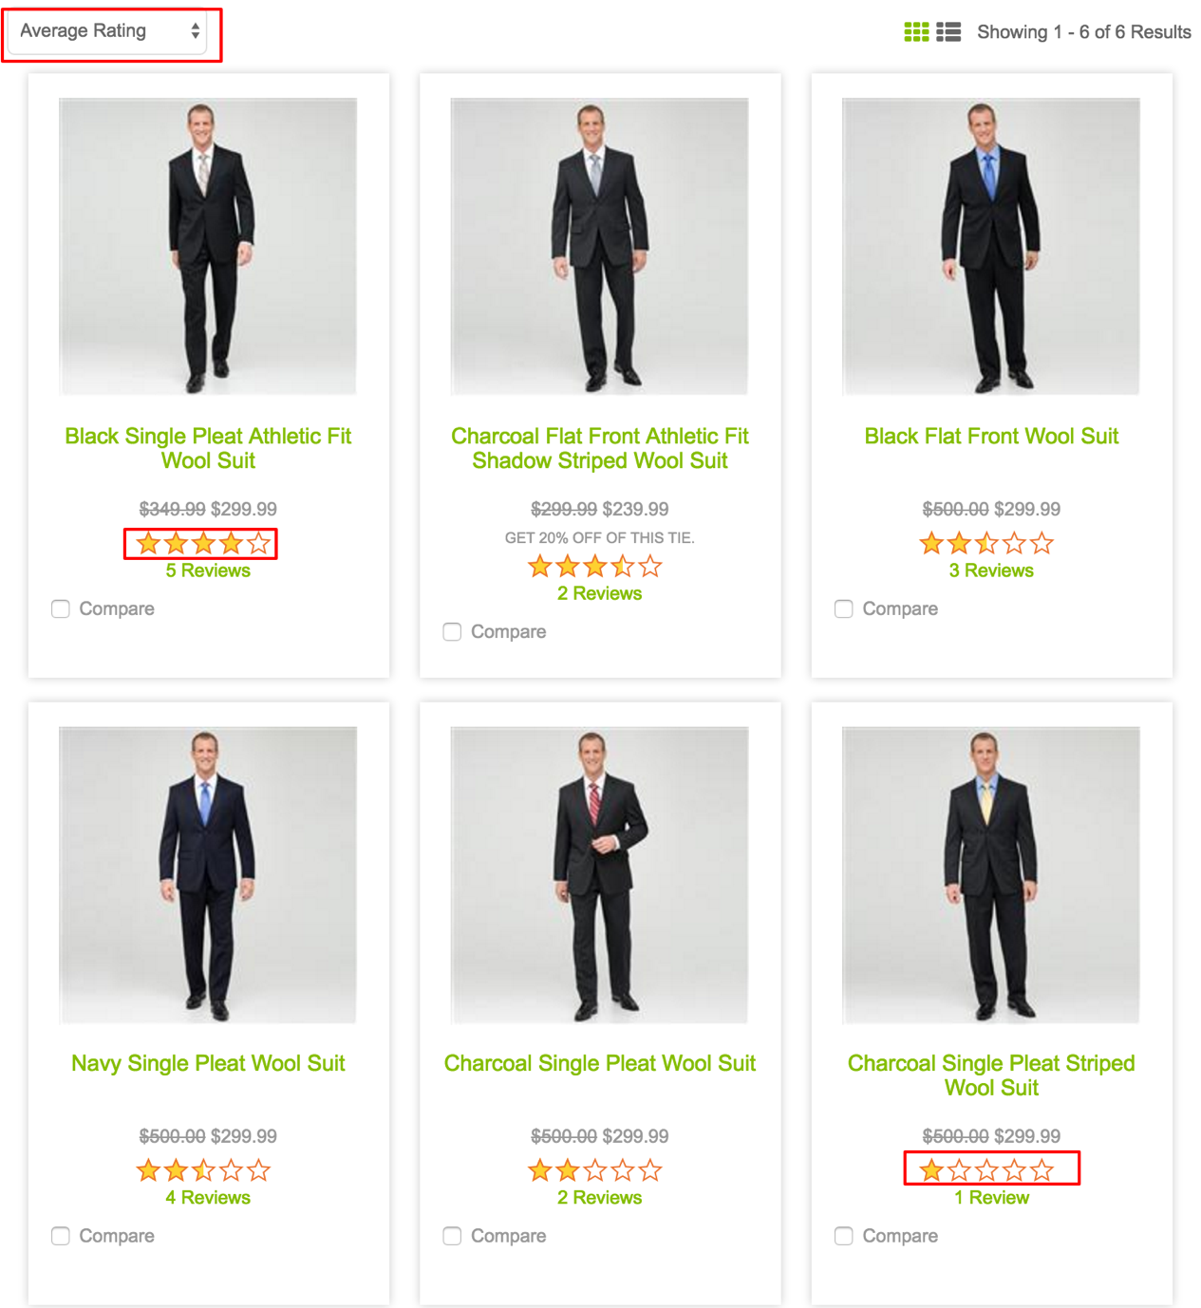

## Custom Code

This section describes the custom code that will need to be added to your storefront. For more information, refer to <http://www.turnto.com/docs> or contact your TurnTo® representative.

### Global Includes

This section requires you have Demandware UX Studio setup and linked to your site. See <https://xchange.demandware.com/docs/DOC-1936> for details.

1. Log in to [www.turnto.com](http://www.turnto.com/) and click on Settings beneath your site name in the left navigation. Copy your "SiteKey" and "AuthKey" from the Manage Site area, and paste them into the associated Custom Site Preferences described in the previous section. These keys will be used in turnToConfig javascript objects to identify you to our systems.
2. In Demandware UX Studio, open the following template in your storefront cartridge: *templates/default/components/header/htmlhead.isml*
3. Add the following code to the bottom of the template file you opened in step 2:  
     
   <isinclude template="turnto/htmlheadinclude"/>

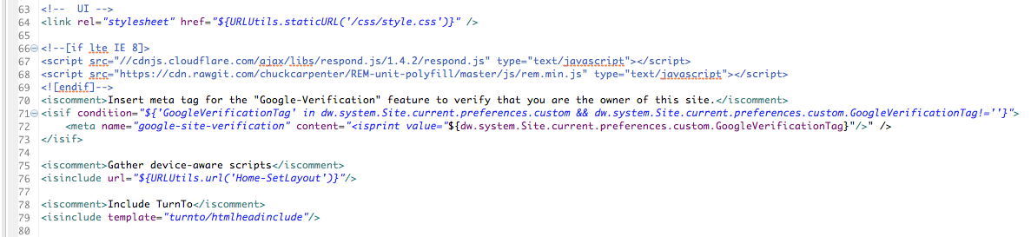

1. Now open the following template in your storefront cartridge: *templates/default/checkout/confirmation/confirmation.isml*
2. Add the following code to the bottom of the template you opened in step 4:  
     
   <isinclude template="turnto/confirmationinclude"/>

The result will look like this:

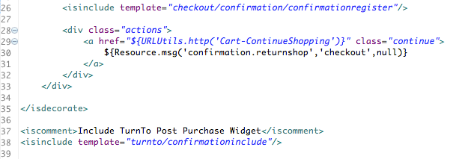

1. The css for the TurnTo widget is in *int_turnto_core/cartridge/static/default/css/turnto.css*. Feel free to modify it to your liking.
2. Flush Site cache
   1. In Demandware Business Manager, Click Sites in the Administration section.
   2. Click "Manage Sites" link.
   3. Click the name of your site. For instance, SiteGenesis.
   4. Click the "Cache" tab.
   5. Invalidate all caches by clicking the "Invalidate" buttons.
3. Flush Business Manager cache
   1. In Demandware Business Manager, Click Sites in the Administration section.
   2. Click "Manage Sites" link.
   3. Click the "Business Manager" link.
   4. Click the "Cache" tab
   5. Invalidate all caches by clicking the "Invalidate" buttons.

### Product Detail Page

#### Teasers (Q&A, R&R)

1. In Demandware UX Studio, open the following template in your storefront cartridge: *templates/default/product/producttopcontent.isml*
2. Add the following code below the h1 for the product name, in the template you opened in step 1:  
     
   <isinclude template="product/components/turntoteasers"/>  
     
   The result will look like this:

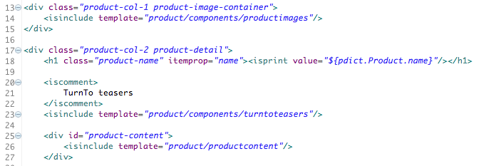



1. If you want bundles and product sets to have the teaser too, add the same code snippet to the following template in your storefront cartridge: *templates/default/product/producttopcontentPS.isml*

#### Widgets (Q&A, R&R, Checkout Comments, Visual Gallery Row)

1. In Demandware UX Studio, open the following template in your storefront cartridge: *templates/default/product/producttopcontent.isml*
2. Add the following code at the END of the template you opened in step 1, before the closing </isif>:  
     
   <isinclude template="product/components/turntoqa"/>  
     
   <isinclude template="product/components/turntoreviews"/>  
     
   <isinclude template="product/components/turntocomments"/>  
     
   The result will look like this:

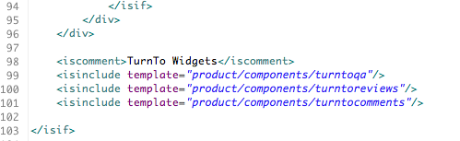

1. Add the following code to the template you opened in step 1, directly after the "product-content" div:  
     
   <isinclude template="product/components/turntogallery"/>  
     
   The result will look like this:

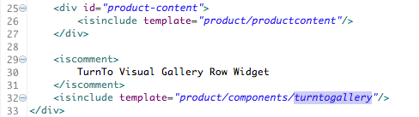

1. If you want bundles and product sets to have the widgets too, add the same code snippet to the following template in your storefront cartridge: *templates/default/product/producttopcontentPS.isml*

### Category and Search Pages

#### Refinements (optional)

NOTE: You will need to have completed the "Configure Average Star Ratings as a Search Refinement" steps under "Configuration" for the refinements to show up.

1. In Demandware UX Studio, open the following template in your storefront cartridge: *templates/default/search/components/productsearchrefinebar.isml*
2. Add the following code after the <isif> check for 'refinementColor', but before the <iselse/>:  
     
   <iselseif condition="${RefinementDefinition.attributeID.equals('turntoAverageRating')}">  
     
   <isinclude template="product/components/turntoratingrefinement"/>  
     
   The result will look like this:

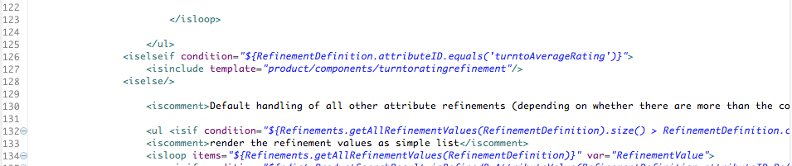

#### Product Tile Teaser (optional)

NOTE: The necessary product data comes from the SKU-to-Average-Rating Feed

In Demandware UX Studio, open the following template in your storefront cartridge: *templates/default/product/components/reviewsmini.isml*

Replace the code inside the div with class="product-review" with the following:  
  
<isinclude template="product/components/turntoteasersproducttile"/>  
  
The result will look like this:

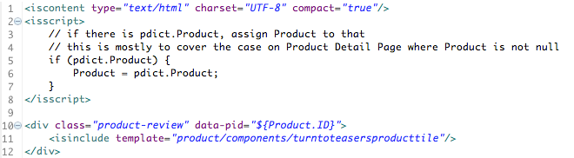

#### Checkout Comments Pinboard Teaser (optional)

1. In Demandware UX Studio, open the following template in your storefront cartridge: *templates/default/rendering/category/catlanding.isml*
2. Put the following code snippet wherever you would like the teaser to appear, likely somewhere in the div with class="secondary-content":  
     
   <isinclude template="product/components/turntopinboardteaser"/>  
     
   The result will look like this:

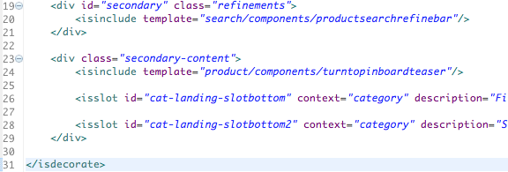

1. Add the same snippet to the other category page as well: *templates/default/rendering/category/categoryproducthits.isml*

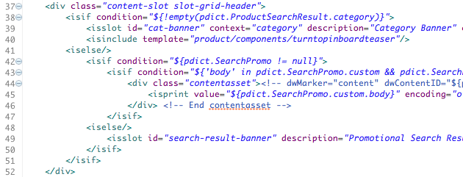



1. Add the snippet to the homepage as well: *templates/default/content/home/homepage.isml*

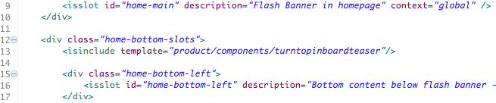

1. A few things to note about the CC Pinboard Teaser:
   1. For ALL pages, the teaser will only show if there are at least 4 products that have 4 buyer comments each
   2. On the home page, or a page without a pdict.ProductSearchResult.category, all products sitewide will be considered for display
   3. On a category page, only the products that belong to that category (defined in the Catalog Feed) will be considered for display
   4. On a category page, only the categories that have the custom attribute turntoEnableCCPinboardTeaser set to true will actually render the teaser